accurx reports
Time frame – the financial year of 24-25 (1/4/24 – 31/3/25)

We signed up to accurx 6 years ago.
On average 7145 messages are sent per month.
These do not include automatic appointment reminder text messages

Below are some reporting tables to give information on how much the Patient Triage is being used when, and the trend. Also, what response to questionnaires we get and the response to self-booking text messages.

The table below shows the volume of patient triage requests we receive
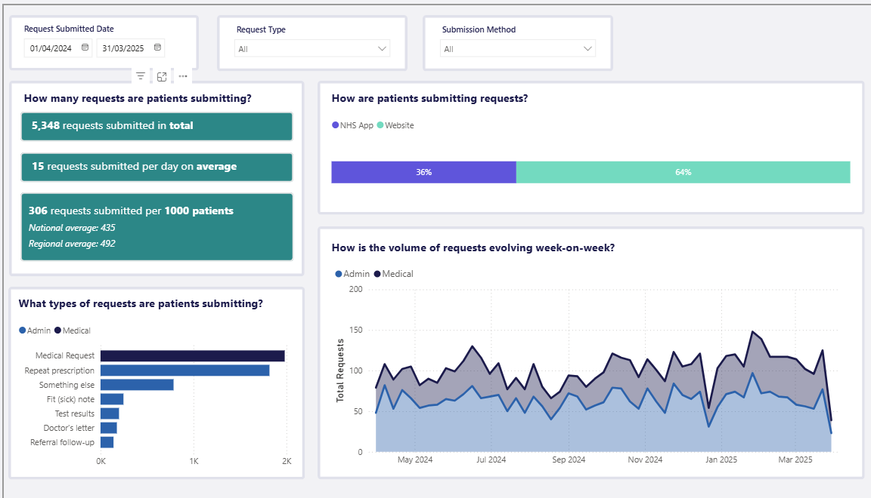
The table below shows when we receive requests. Most are received on a Monday and Tuesday. The ones sent on a Saturday or Sunday are looked at on the Monday.

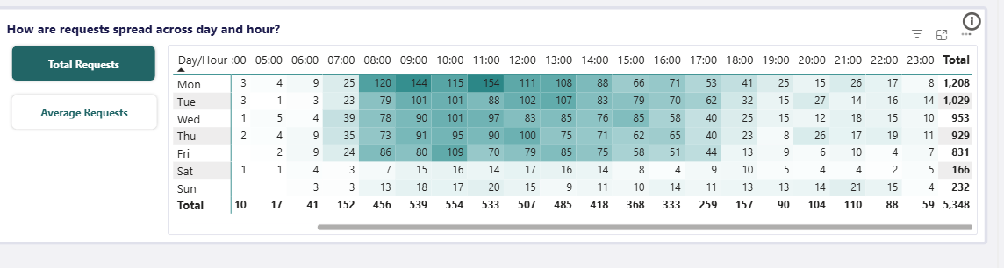

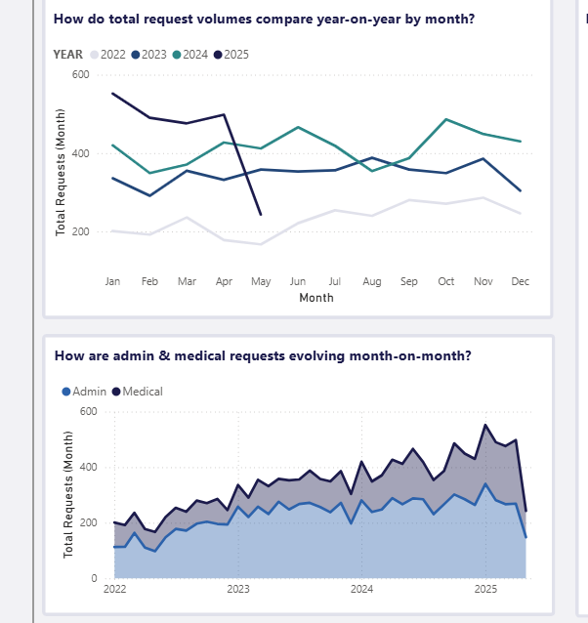
These tables show the number of accurx patient triage requests has increased year upon year.

We send questionnaires out to patients to fill in. Below is the response rate for them.

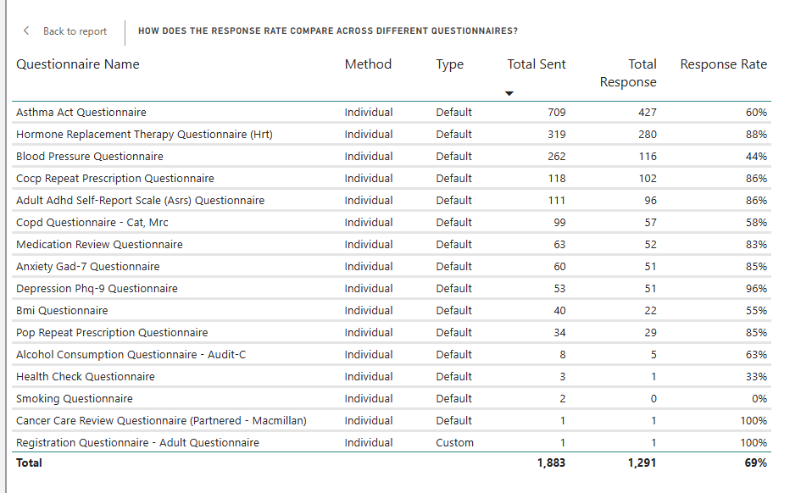
The table below shows how many text messages are sent with a self-booking link for a particular appointment slot.
Individual booking links have an average response rate of 32%
Batch booking links have an average response rate of 22%
25% of patients respond to booking links within 3 days.
Booking Slot | Appt Type | Method | Total Sent | Total Response | Booking Response Rate
Flu Injection | FaceToFace | Batch | 3,640 | 919 | 25%
Routine | FaceToFace | Individual | 1,925 | 356 | 18%
Pharmacist Telephone Appointment | Telephone | Individual | 888 | 460 | 52%
Routine | FaceToFace | Batch | 839 | 51 | 6%
Rsv Injection | FaceToFace | Batch | 669 | 170 | 25%
Child Flu | FaceToFace | Batch | 492 | 113 | 23%
Long Term Conditions | FaceToFace | Individual | 426 | 182 | 43%
Tel Appt Gp | Telephone | Individual | 110 | 59 | 54%
Routine Hcas | FaceToFace | Individual | 81 | 25 | 31%
Face To Face | FaceToFace | Individual | 52 | 33 | 63%
Pharmacist Telephone Appointment | FaceToFace | Individual | 52 | 16 | 31%
Flu Injection Under 65s Only | FaceToFace | Batch | 41 | 6 | 15%
Pharmacist Face To Face Appointment | FaceToFace | Individual | 17 | 6 | 35%
Flu Injection | FaceToFace | Individual | 12 | 7 | 58%
Health Check For 40 To 74yrs Olds | FaceToFace | Individual | 12 | 7 | 58%
Cervical Smear | FaceToFace | Individual | 6 | 1 | 17%
Anti Coagulation | FaceToFace | Individual | 4 | 0 | 0%
Tel Appt Gp | FaceToFace | Individual | 4 | 1 | 25%
Routine | Telephone | Individual | 3 | 3 | 100%
Coil Related Telephone Only | Telephone | Individual | 2 | 2 | 100%
Pharmacist Face To Face Appointment | Telephone | Individual | 2 | 1 | 50%
RSV Injection | FaceToFace | Individual | 2 | 1 | 50%
Urgent Nurses | Telephone | Individual | 2 | 0 | 0%
Child Flu | FaceToFace | Individual | 1 | 0 | 0%
Face To Face | Telephone | Individual | 1 | 0 | 0%
Face To Face, Appt Outside Core Hours | FaceToFace | Individual | 1 | 0 | 0%
Long Term Conditions | Telephone | Individual | 1 | 0 | 0%
Long Term Conditions Appt Outside Core Hours | FaceToFace | Individual | 1 | 0 | 0%
Pharmacist To Book Only | Telephone | Individual | 1 | 1 | 100%
Routine, Appt Outside Core Hours | FaceToFace | Individual | 1 | 1 | 100%
Total |  |  | 9,288 | 2,421 | 26%

Surgery Connect – our phone system.
Statistics for the financial year 24-25
